

EC-200 Data Structures
LAB MANUAL # 02

Course Instructor: Dr. Anum Abdul Salam

Lab Engineer: Engineer Hira Irshad

Student Name: _______________________________________________

Degree/ Syndicate: ____________________________________________

 | Trait | Obtained Marks | Maximum Marks
R1 | Application Functionality 20% |  | 20
R2 | Specification & Data structure implementation  30% |  | 30
R3 | Reusability  10% |  | 10
R4 | Input Validation  10% |  | 10
R5 | Efficiency  20% |  | 20
R6 | Delivery  10% |  | 10
R7 | Plagiarism above 60% |  | 0
 | Total |  | 100

Total Marks = O𝒃𝒕𝒂𝒊𝒏𝒆𝒅 𝑴𝒂𝒓𝒌𝒔 (∑⁶_{𝟏} 𝑹_{𝒊} ∗ 𝑹₇)
Lab #02: Implementation of Linked List

Lab Objective:
To implement Linked List ADT functions.
Lab Description:
Arrays are used to save data in memory. As long as the program runs, our program can read/write data to arrays. Some pros and cons of arrays are
+ Fast element access.
-- Impossible to resize.
- Many applications require resizing!
- Required size not always immediately available.
To overcome the cons of arrays, solution was proposed in form of Linked lists. Linked lists are type of data structure that provide resize ability at run time with small computational complexity as compared to dynamic arrays.
Linked List:
Linked List is a collection of data in which each element contains the location of the next element.
- Each element contains two parts: data and link.
- The link contains a pointer (an address) that identifies the next element in the list.
Both an array and a linked list are representations of a list of items in memory. The only difference is the way in which the items are linked together. Figure compares the two representations for a list of five integers.
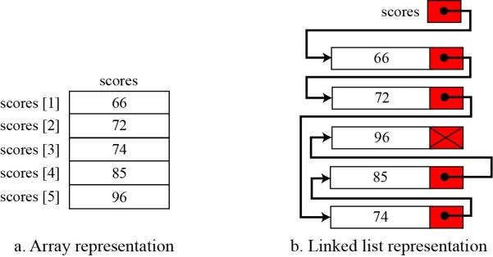
Figure 2.1 Array vs. Linked List Representation
Nodes: Nodes are the basic building elements in a linked list. The nodes in a linked list are called self-referential records because each instance of the record contains a pointer to another instance of the same structural type.

Basic Operations in linked list ADT:
- Insertion (Start, End, Any position)
- Deletion (Start, End, Any position)
- Searching or Iterating through the list to display items.

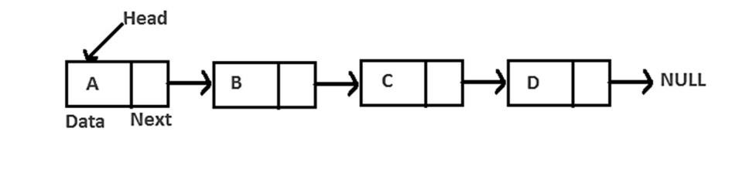
Figure 2.2 Singly Linked List

Inserting at the start
- Allocate a new node
- Insert new element
- Make new node point to old head
- Update head to point to new node
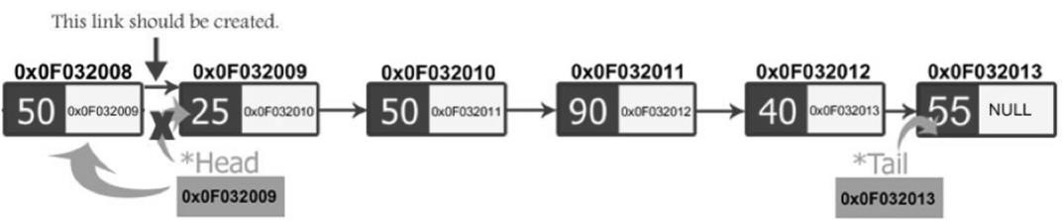

Figure 2.3 Insert Node at Start
Insert first node | Insert at start
void insertFirstNode (int v)  { node *head=new node; head->data=v; head->next=NULL;  } | void insert(int v)  { node *p=new node; p->data=v; p->next=head; head=p;  }

Inserting at any position
1. Allocate a new node
- Insert new element.
- Access address of previous node from the position you want to insert and address of current node (position node).
- Pass the address of the new node in the next field of the previous node.
- Pass the address of the current node in the next field of the new node.
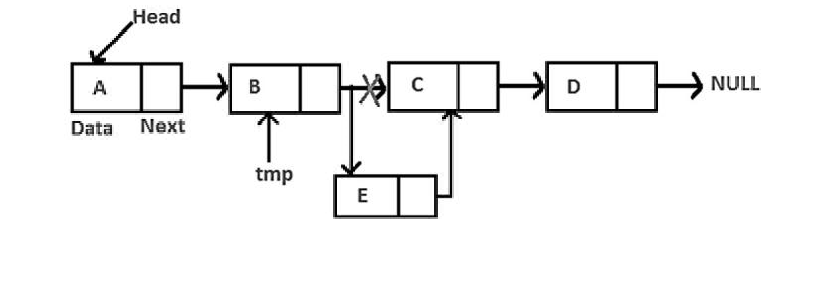
Figure 2.4 Insert Node at Any Position
We will access these nodes by asking the user at what position he wants to insert the new node. Now, we will start a loop to reach those specific nodes. We initialized our current node by the head and move through the linked list. At the end, we would find two consecutive nodes.
Delete at start
void delete_first()
{
node *temp=new node;
temp=head; head=head->next; delete temp;
Delete from start
- Update head to point to next node in the list
- Allow garbage collector to reclaim the former first node 3. De allocate the first node

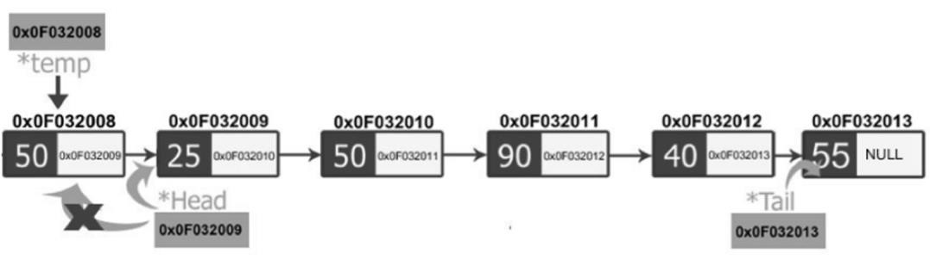
Figure 2.5 Delete from Start

Delete from end
- Make two temporary pointers (previous and current) and find nodes that comes before the last node.
- Previous node will point to the second to the last node and the current node will point to the last node, i.e., node to be deleted.
- Delete current node and make the previous node as the tail.
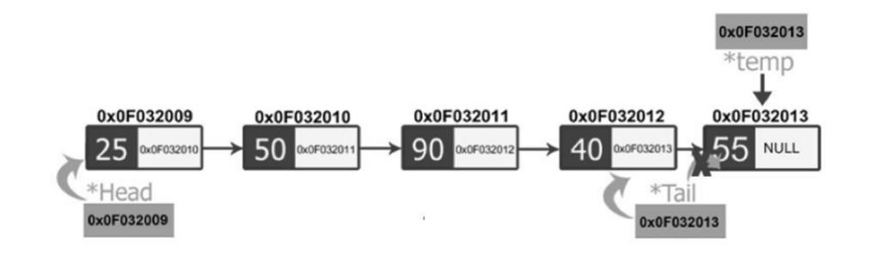
Figure 2.6 Delete from End
Delete at any Position
- Make two temporary pointers (previous and current) and traverse until find a specific node which needs to be deleted.
- Delete respective node and pass the address of the node after it to the previous node.
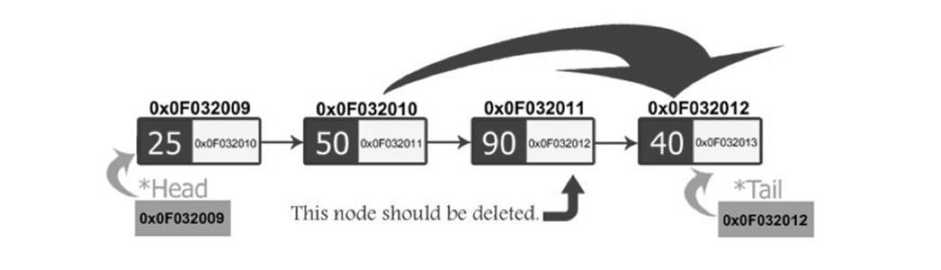
Figure 3.7 Delete from any Position
CAUTION!!Always make sure that your linked list functions work correctly with an empty list.Empty Linked list is a single pointer having the value of NULL.
head = NULL;

LAB TASK:
1. Complete your Linked List class from the pre-lab task by adding the following functions:
- InsertAtAnyposition(intposition,intval)
- DeleteAtAnyposition(node)
- Copy constructor
- Destructor
2. Create a templated Linked List ADT and provide
- Constructor / copy constructor
- Destructor
- InsertAtStart(intval)
- InsertAtAnyposition(intposition,intval)
- insertAtEnd(intval)
- deleteAtstart()
- DeleteAtAnyposition(node)
- deleteAtEnd()
- Traverse()
- isEmpty()
Note: Your program should have no memory leakage & dangling pointers. Your program should be validated properly and display warnings and errors to user as well. Reuse functions if needed to increase program efficiency.
TEST PLAN:
1. Execute your test plan. If you discover mistakes in your implementation of the List ADT, correct them and execute your test plan again.
Sr. | Operations | Expected Results | Results/Status
1. | Create an integer type list myList with default constructor | head=NULL
2. | Copy constructor | Head = NULL
3. | Check if the list isEmpty? | yes
4. | Insert values 1-5 in list
5. | Check if the list isEmpty? | No
6. | Traverse the list | 1,2,3,4,5
7. | Delete from start
8. | Traverse the list | 2,3,4,5
9. | Insert at Start (6)
10. | Traverse the list | 6,2,3,4,5
11. | Insert at End (9)
12. | Traverse the list | 6,2,3,4,5,9
13. | Delete from end
14. | Traverse the list | 6,2,3,4,5
15. | Delete from position 3
16. | Traverse the list | 6,2,4,5
17. | Insert value 7 at position 4
18. | Traverse the list | 6,2,4,7,5
19. | Delete from start
20. | Traverse the list | 2,4,7,5
21. | Delete from position 2
22. | Traverse the list | 2,7,5
23. | Delete from start
24. | Delete from start
25. | Delete from start
26. | Traverse the list | List is Empty

3. A hospital emergency department manages incoming patients using a priority-aware waiting list. The list frequently changes as patients arrive, are treated, transferred, or when emergency cases appear. Due to these frequent insertions and removals at different positions, a contiguous memory structure is not suitable.
You are required to design a system that models this patient list.
Each patient record contains:
- Patient ID (unique)
- Patient Name
- Condition Severity Level (1 = Critical, 2 = Serious, 3 = Stable)
System Requirements:
- Initialization
  - When the system starts, the patient list is empty.
  - The system should also support starting with one already registered patient
- Patient Arrival
  - A new patient may arrive in three possible situations:
    - A critical patient must be placed immediately at the front of the list.
    - A stable patient is placed at the end of the list.
    - A serious patient must be placed after all critical patients but before stable patients.
  - The system must correctly place patients based on their severity level.
- Patient Treatment / Removal
  - When treatment begins:
    - The first patient in the list is treated and removed.
  - If a patient leaves the hospital or is transferred, the system should remove that patient based on Patient ID, regardless of their position.
  - At the end of the day, the last remaining patient (if any) may be discharged.
- Search Operation
  - The hospital staff must be able to check whether a patient exists in the waiting list using the Patient ID and display their details if found.
- Daily Backup
  - At the end of each shift, the hospital creates a complete backup copy of the current patient list.
  - This backup must be independent of the original list so that changes in one do not affect the other.
- Display
  - The system should display the complete list of patients in order, showing:
    - Patient ID
    - Name
    - Severity Level
- Memory Management
  - When the system shuts down, all allocated memory must be released properly.
Constraints:
- Patient IDs are unique.
- No fixed limit on the number of patients.
- Order of patients must always reflect the severity rules.
- Backup list must remain unchanged even if the original list is modified later.
Test Plan:
Test Case | Sample Input / Action | Output
Start system with no patients | Initialize system
Start system with one transferred patient | Initialize with Patient(101, Alia, Critical)
Add critical patient | Add Patient(102, Saba, Critical)
Add stable patient | Add Patient(103, Ahmed, Stable)
Add serious patient | Add Patient(104, Ayesha, Serious)
Multiple critical patients | Add another critical
Multiple stable patients | Add another stable
Remove patient for treatment | Treat next patient
Remove patient by ID (middle) | Remove ID = 104
Remove patient by ID (last) | Remove last patient
Attempt to remove non-existent patient | Remove ID = 999
Search existing patient | Search ID = 102
Search non-existing patient | Search ID = 888
Create backup at shift end | Create backup copy
Modify original after backup and display both original and backup | Remove patient from original
Modify backup and display both original and backup | Add patient to backup
Discharge last remaining patient | Discharge patient
Display empty list | Display patients
System shutdown | Exit program

THINK:
- What if we do not initialize head=NULL?
- Write 2 applications where linked lists are preferable than arrays.
- Can we access any node within the list directly using node’s index like arrays?

